
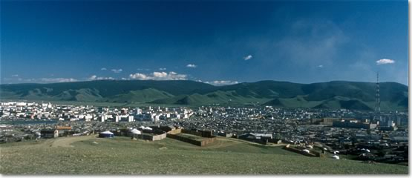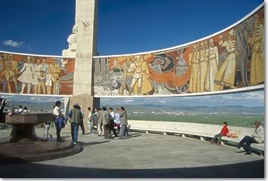
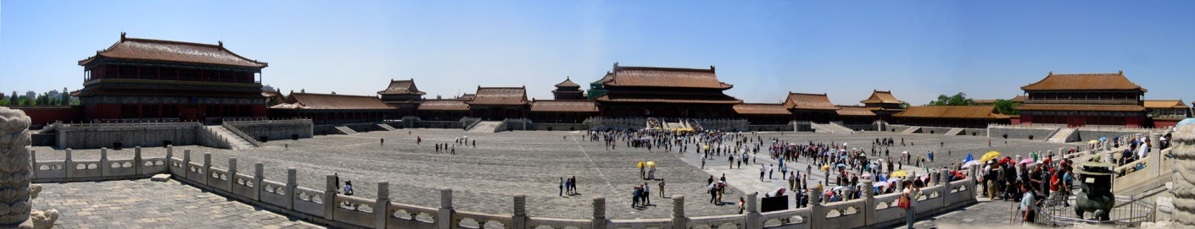

A key difference WISE is a J-1 visa program sponsor, not a placement agency or a staffing company, and we place our J-1 Visa program participants at accredited jobs/employers, while providing for those employers a reliable staffing resource. All WISE Foundation participants are paid directly by your company, on your own payroll. They are your employees. WISE doesn’t charge any fee to the employers. WISE conducts international job fairs, where you can interview face-to-face our participants.

- WISE trips are FREE if you hire 35+ students
- If you hire less than 35 but are still interested in a attending the job fair, we will cover part of your cost.
- You will have fun traveling around the World for FREE and getting to know new places!

If you have scheduling conflicts, please let us know, and we will offer a solution for your hiring/recruiting needs. The WISE Foundation is very flexible to meet your requirements, and we can customize our selection process to best suit your criteria and requirements. We can match our candidates to the jobs you are offering, and forward their resumes for your review and selection; or we can also organize phone or web-cam interviews for you.

Contact Eduardo Voloch at eduardo@wisefoundation.com or 770-579-0567 for additional details.

